**Lesson 10**Best Programming Practices with Java 8:*Living Life in Accord with Natural Law*

**Wholeness of the Lesson**

Best practices in the world of OO programming are a way of ensuring quality in code. Code that adheres to best practices tends to be easier to understand, easier to maintain, more capable of adapting to change in the face of changing requirements and new feature requests, and more reusable for other projects. This simple theme is reflected in individual life. There are laws governing life, both physical laws and laws pertaining to all kinds of relationships and interactions. When life flows in accordance with the laws of nature, life is supported for success and fulfillment. When awareness becomes established at its deepest level, actions and behavior springing from this profound quality of awareness spontaneously are in accord with the laws of nature.

**Overview**

1. **Test-Driven Development and Unit Testing (Optional Module #1)**
2. Unit-testing Stream Pipelines
3. Introduction to Annotations
4. Review of Exception Handling in Java (Optional Module #2)
5. Handling Exceptions Using Java 8’s try-with-resources
6. Review of Basic JDBC Programming (Optional Module #3)
7. Advanced JDBC Programming
8. Handling Exceptions Arising in Stream Pipelines
9. Concurrent Processing and Parallel Streams

**The Test-Driven Development (TDD) Paradigm**(Optional Module #1)

1. The TDD paradigm says that the best testing strategy is to develop tests as part of the implementation process. Some even say that test code for a method or a class should be written before the actual code for the method or class is written. (TDD originated in the Extreme Programming development process, but is used these days regardless of the process used.)

2. TDD follows these steps

1. First the developer writes an (initially failing) automated test case that defines a desired improvement or new function
2. Next he produces the minimum amount of code to pass that test
3. Finally, he refactors the new code to acceptable standards.

3. Benefits of TDD (See the Wikipedia article)

1. Studies
   1. A 2005 study found that using TDD meant writing more tests and, in turn, programmers who wrote more tests tended to be more productive.
   2. Madeyski (Springer, 2010) provided an empirical evidence (involving 200 developers) that the TDD approach led to bettter OO design and more thorough and effective testing of a code base than the Test-Last approach.
   3. Surveys of developers (many examples of this) reveal that developers find significantly less need to debug code when they use TDD.
   4. Müller and Padberg ( ["About the Return on Investment of Test-Driven Development"](http://www.ipd.kit.edu/KarHPFn/papers/edser03.pdf) – pdf available online) showed that, while it is true that more code is required with TDD, the total code implementation time is often shorter.
2. *Better handling of requirements.* Since coding is closely related to testing, developer tends to think more effectively about how the code will be used – the result is that requirements are met with at a higher success rate.
3. *Catch defects early* – this leads to a reduction in overall cost
4. *Modular, flexible, extensible code.*TDD leads to more modularized, flexible, and extensible code because developers think of the software in terms of small units that can be written and tested independently and integrated together later

4. Example (see package lesson10.lecture.tdd)

Best Practices When Unit-Testing  
(Optional Module #1)

* Separate common set up logic into support methods.
* Keep each test focused on only the results necessary to do the necessary validation..
* Treat your test code with the same respect as your production code. It also must work correctly for both positive and negative cases, last a long time, and be readable and maintainable. In particular, tests should not depend on data or other aspects of the system that are likely to change (example: relying on the number of records in a table as part of a test)

***Things to avoid***

* Having test cases depend on system state manipulated from previously executed test cases.
* Dependencies between test cases. A test suite where test cases are dependent upon each other is brittle and complex. Execution order should not be presumed.
* Building “all-knowing oracles.” An oracle that inspects more than necessary is more expensive and brittle over time.
* Slow running tests.

**Unit-Testing Tools**(Optional Module #1)

|  |  |
| --- | --- |
| **Tool** | **Description** |
| **Cactus** | A [JUnit](http://en.wikipedia.org/wiki/JUnit) extension for testing [Java EE](http://en.wikipedia.org/wiki/Java_EE) and web applications. Cactus tests are executed inside the [Java EE](http://en.wikipedia.org/wiki/Java_EE)/web container. |
| **GrandTestAuto** | Comprehensive Java software test tool not related to xUnit series of tools |
| **Jtest** | Commercial unit test tool that provides test generation and execution with code coverage and runtime error detection |
| **JUnit 4.0** | Standard unit test tool; more flexible with release of version 4.0 |
| **JUnitEE** | A variant of JUnit that provides JEE testing |
| **Mockito** | Unit testing with mock objects |
| **TestNG** | Actually a multi-purpose testing framework, which means its tests can include unit tests, functional tests, and integration tests. Further, it has facilities to create even no-functional tests (as loading tests, timed tests). It uses Annotations since first version and is a framework more powerful and easy to use than the most used testing tool in Java: JUnit |

**Review: Setting Up JUnit 4.0**(Optional Module #1)

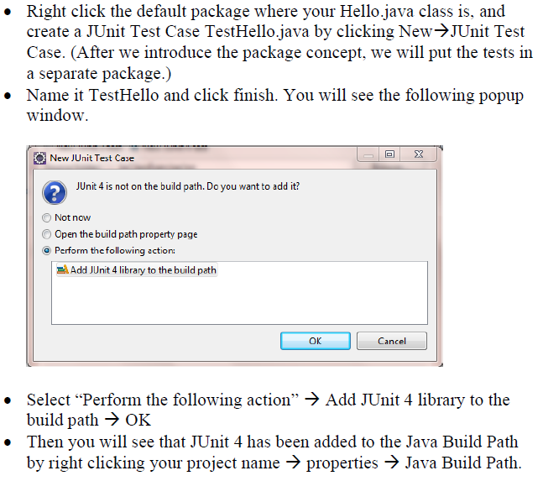

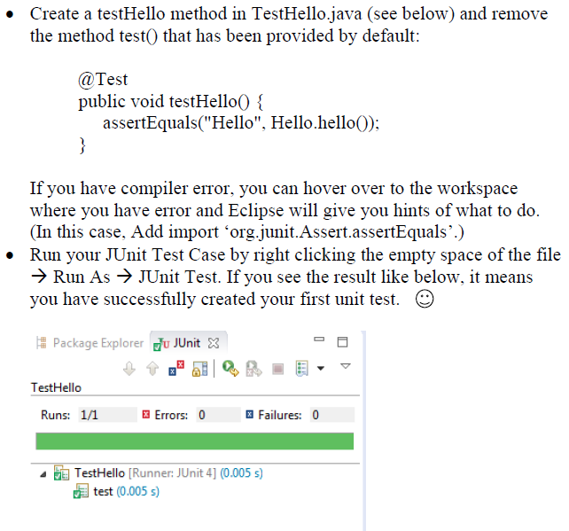

* Methods that are annotated with @Test can be unit-tested with JUnit.
* Three most commonly used methods:  
   assertTrue(String comment, boolean test)  
   assertFalse(String comment, boolean test)  
   assertEquals(String comment, Object ob1, Object ob2)  
  In each case, when test fails, comment is displayed (so it should be used to say what the expected value was).

Demo: TDD Example Using JUnit 4.0 – see lesson10.lecture.tddxxx

**Overview**

1. Test-Driven Development and Unit Testing (Optional Module #1)
2. **Unit-testing Stream Pipelines**
3. Introduction to Annotations
4. Review of Exception Handling in Java (Optional Module #2)
5. Handling Exceptions Using Java 8’s try-with-resources
6. Review of Basic JDBC Programming (Optional Module #3)
7. Advanced JDBC Programming
8. Handling Exceptions Arising in Stream Pipelines
9. Concurrent Processing and Parallel Streams

**How to Unit Test Stream Pipelines?**

1. The Problem. Stream pipelines, with lambdas mixed in, form a single unit; it is not obvious how to effectively unit test the pieces of the pipeline.
2. Two Guidelines:
   1. If the pipeline is simple enough, we can name it as an expression and unit test it directly.
   2. If the pipeline is more complex, pieces of pipeline can be called from support methods, and the support methods can be unit-tested.

**Unit-Testing Stream Pipelines:**   
Simple Expressions

* Example: Test the expression:

Function<List<String>, List<String>> allToUpperCase =

words -> words.stream()

.map(word -> word.toUpperCase())

.collect(Collectors.toList());

* Can do ordinary unit testing of the allToUpperCase

@Test

**public void** multipleWordsToUppercase() {

List<String> input = Arrays.asList("a", "b", "hello");

List<String> result = Testing.allToUpperCase.apply(input);

assertEquals(asList("A", "B", "HELLO"), result);

}

**Unit-Testing Lambdas:**  
 Complex Expressions

* Example:

Function<List<String>, List<String>> elementFirstToUpperCaseLambdas =

words -> words.stream().map(word ->   
 {

char firstChar = Character.toUpperCase(word.charAt(0));

return firstChar + word.substring(1);

}

).collect(Collectors.toList());

}

* The key point to test is whether the expression for transforming a word so that its first letter becomes upper case is working.
* This can be done by replacing the lambda expression with a method reference together with an auxiliary method which can be placed in a companion class LibraryCompanion

public static List<String> elementFirstToUpperCaseLambdas(List<String> words) {

return words.stream().map(LibraryCompanion::firstToUpper)   
 .collect(Collectors.toList());

}

//auxiliary method, used in method reference, in the class LibraryCompanion

public static String firstToUpper(String value) {

char firstChar = Character.*toUpperCase*(value.charAt(0));

return firstChar + value.substring(1);

}

* Now the key element of the original lambda can be tested directly.

@Test

**public void** twoLetterStringConvertedToUppercase() {

String input = "ab";

String result = LibraryCompanion.firstToUpper(input);

assertEquals("Ab", result);

}

**Unit-Testing Lambdas:**  
 Complex Expressions

The example suggests a best practice for unit testing when lambdas are involved:

1. Replace a lambda that needs to be tested with a method reference plus an auxiliary method
2. Then you can test the auxiliary method

**Main Point 1**

Unit testing, in conjunction with Test-Driven Development, make it possible to steer a mistake-free course as programming code is developed. The self-referral mechanism of anticipating logic errors in unit tests, developed as the main code is developed, is analogous to the mechanism that leads awareness to be established in its self-referral basis; action from such an established awareness tends to make fewer mistakes.

**Overview**

1. Test-Driven Development and Unit Testing (Optional Module #1)
2. Unit-testing Stream Pipelines
3. **Introduction to Annotations**
4. Review of Exception Handling in Java (Optional Module #2)
5. Handling Exceptions Using Java 8’s try-with-resources
6. Review of Basic JDBC Programming (Optional Module #3)
7. Advanced JDBC Programming
8. Handling Exceptions Arising in Stream Pipelines
9. Concurrent Processing and Parallel Streams

**What Are Annotations?**

1. We have seen them in various contexts already:
   1. @Test - JUnit 4
   2. @Override – to indicate (with compiler check) that a method is being overridden
   3. @FunctionalInterface – to indicate that an interface is functional and may be used with lambdas
   4. @Deprecated – to discourage use of a method or class
   5. @SuppressWarnings – to hide warning messages of various kinds
   6. Javadoc annotations:
      1. @author
      2. @since
      3. @version
2. Annotations are tags that are inserted into source code so that some tool can process them. The tools can operate on the source level, or they can process class files into which the compiler has placed annotations.
3. To benefit from annotations that you create, you need to select a *processing tool*. You need to use annotations that your processing tool understands, then apply the processing tool to your code.  
     
   - JUnit processes its @Test annotation

- Java compiler processes the others shown

1. Annotations can be applied to a class, a method, a variable – in fact, anywhere qualifilers like public and static may be used
2. Annotations may have zero or more *elements.* Here is an example of a user-defined annotation that has two elements, assignedTo and severity.

@BugReport(assignedTo="Harry", severity=10)  
  
[This annotation could be applied at the class level. Like any users-defined annotation, it would require an external tool to process it.]

1. When an annotation has just one element and its name is “value”, the following more compact form can be used:

@SuppressWarnings("unchecked")

[same as @SuppressWarnings(value = "unchecked")]

1. If the annotations have the same type, then this is called a repeating annotation:

@Author(name = "Jane Doe")

@Author(name = "John Smith")

class MyClass { ... }

Repeating annotations are supported as of the Java SE 8 release

1. *User-defined annotations*. The @interface keyword is the way the Java compiler knows you are creating an annotation; such “classes” extend the Annotation interface.  
     
   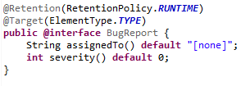

See the demo lesson10.lecture.annotation

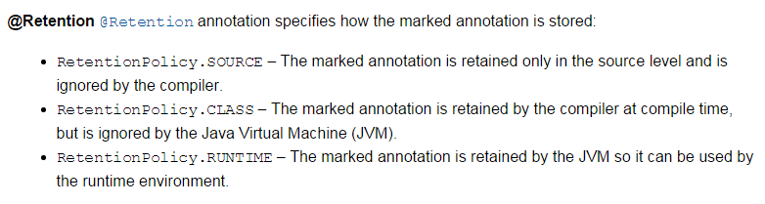

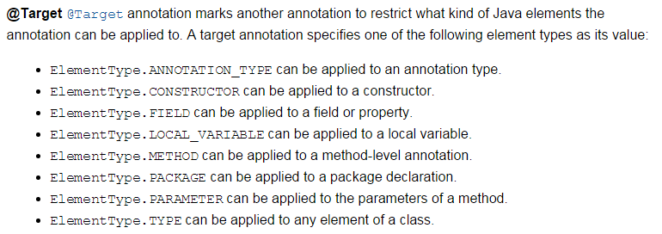

**Overview**

1. Test-Driven Development and Unit Testing (Optional Module #1)
2. Unit-testing Stream Pipelines
3. Introduction to Annotations
4. **Review of Exception Handling in Java (Optional Module #2)**
5. Handling Exceptions Using Java 8’s try-with-resources
6. Review of Basic JDBC Programming (Optional Module #3)
7. Advanced JDBC Programming
8. Handling Exceptions Arising in Stream Pipelines
9. Concurrent Processing and Parallel Streams

**Review of Exception-Handling in Java**(Optional Module #2)

In Java, error conditions are represented by Java classes, all of which inherit from Throwable.

|  |
| --- |
|  |
| **The Hierarchy of Exception Classes** |

**Classification of Error-Condition Classes**(Optional Module #2)

In Java, error-condition classes belong to one of three categories:

* *Error* – Objects in this category belong to the inheritance hierarchy headed by the Error class. Examples include OutOfMemoryError, StackOverflowError, VirtualMachineError. If these are thrown, it indicates an unrecoverable error and the application should terminate.
* *Other Unchecked Exceptions –* Besides Error objects, unchecked exceptions include all objects that belong to the inheritance hierarchy headed by the class RuntimeException. Examples include NullPointerException, ArrayIndexOutOfBoundsException, NumberFormatException. When these are thrown, it indicates that a programming error has occurred and needs to be fixed. Typically, these types of exceptions are not caught and handled – they simply indicate that some logic error needs to be corrected.
* *Checked Exceptions* – Exceptions in this category are subclasses of Exception

but not subclasses of RuntimeException. Examples include FileNotFoundException, IOException, SQLException. The idea behind checked exceptions is that it should be possible to handle them in such a way that the application can continue; for example, if a database is unavailable, a SQLException would be thrown, and the user could be given the option to continue on to other features of the application even if the database is down for awhile.

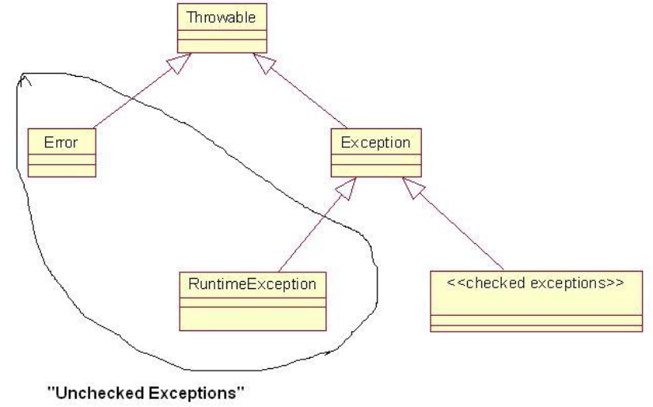

Four Ways to Deal with Checked Exceptions  
(Optional Module #2)

1. Declare that your method throws the same kind of exception (and do not handle the exception)
2. Put the exception-creating code in a try block, and write a catch block to handle the exception in case it is thrown – in other words, use try/catch blocks.
3. Use try/catch blocks – catch block can log information about the current state – and then re-throw the exception. In this case, as in (1), you must declare that the method throws this type of exception
4. Use try/catch blocks as in (3), but, when an exception is caught, wrap it in a new instance of another type of exception class and re-throw

See Demo lesson10.lecture.checkedexceptions

**Summary of Best Practices**(Optional Module #2)

1. *Log when exception first arises.* When an exception is first caught, information about the state of the object should be logged – logging can be done in a catch block. However, if the try/catch are inside a loop that has many iterations or that could even possibly fail to terminate, logging should be done outside the loop.

|  |  |
| --- | --- |
|  |  |
| **Obtain instance of jdk Logger** | **Write to the LOG. Use LOG.severe, LOG.warning, LOG.info, LOG.fine** |

1. *Handler of exception should be chosen carefully.* An exception should be handled by an object that “knows” what to do with the exception – typically, it should have the responsibility of communicating a message to the user. Therefore, when an exception is thrown, it should propagate up the call stack until it reaches an appropriate handler.
2. *Never create an “empty” catch block.* Exceptions should never be ignored, as in

This is *so* bad…

try { . . .

} catch {}

If nothing needs to be done, there should at least be a comment stating this fact – and probably some message to the log – rather than dead silence.  
 try { . . .

This is acceptable

} catch {

//nothing needed here

LOG.info(“Exception thrown by . . .”);

}

1. *Never catch Exception or Throwable.* Your code should (almost) never catch Exception or Throwable. One reason is that doing so means that you will be handling any RuntimeExceptions that are thrown (like NullPointerException), and these should not be caught. [One exception to this rule arises sometimes when communicating with external APIs – it may not always be possible to anticipate which types of Exceptions will be thrown by API methods, and you may want to make sure your application does not shut down because of an uncaught exceptions coming from the outside.]
2. *Always validate input arguments.* Important methods that take input arguments should validate input values and throw an IllegalArgumentException in case of invalid inputs.

void myMethod(String arg) {

if(arg == null || arg.length() == 0)

throw new IllegalArgumentException(“Input must be nonempty”);

//more

}

Note that throwing any type of RuntimeException never requires a throws declaration.

1. *Don’t throw instances of RuntimeException.* If you need to throw some kind of runtime exception, either use one of the specific subclasses of RuntimeException available in the Java libraries (as in the previous example: IllegalArgumentException, or others: IllegalStateException, NumberFormatException) or, if nothing fits, create your own subclass of RuntimeException. Never simply throw a RuntimeException – it is too general.

|  |  |
| --- | --- |
|  | This is *bad*… |
|  |  |
|  | This is *good*… |

7. *Using a finally block*.

A. *Always executes*. When finally is used, the code in the finally block is executed even if the try block succeeds and returns (finally block executes before performing the return) or an exception is thrown. When an exception is thrown and caught, before control is passed up the stack, finally clause executes; when it is not caught, before a stack trace is displayed, finally clause is executed.

B. *Used for cleanup.* Traditionally, finally is used to clean up resources before exiting the application. Files are closed, database connections closed, etc. Java 7/8 provides a new approach (*try with resources*) to handle this pattern – discussed below

C. *No return statement in a finally block.* A return statement should not occur in a finally block – if the try block also has a return statement, then the finally block’s return statement will be the one that executes.

D. *Do not throw an exception within a finally block.* An exception should not be thrown from within a finally block – if an exception is thrown during execution of the try block, and then in the finally block another exception is thrown, the exception from the finally block is the one that is actually thrown.

**Setting up the JDK Logger**(Optional Module #2)

1. The JDK Logger can always be accessed like this:

private final static Logger LOG = Logger.getLogger(<any string>)

The string argument should be the current package name. Typical way of obtaining this string:  
 MyClass.class.getPackage().getName();  
  
The top-level logger is indicated by the empty string “”:  
 Logger LOG = Logger.getLogger(“”);  
  
There is also a global logger that can be obtained like this:  
 Logger LOG = Logger.getGlobalLogger();  
For smaller applications, this one is fine to use.

1. Configuring the Logger
2. For production-quality logging, configuration should be done using the logging.properties file that comes with Java. Details about this are available in the setup folder for this course in the directory logging. (This is an FPP topic.)
3. Log configuration can also be done in code. For this course, the logger can be configured using logsetup.jar. The global logger can be configured using this jar file with a call (in application startup):  
    LogSetup.*setup*();  
   The setup method does the following:
4. Provides simple output messages to the console. You can create one of these messages with these calls:  
    LOG.config(<message>), LOG.info(<message>),

LOG.warning(<message>), LOG.severe(<message>)

1. Provides XML-formatted messages to a log file, placed at the top level of your src directory: src\logs

Demos: lesson10.lecture.logging.defaultlogging, lesson10.lecture.logging.defaultlogging2

**Tricky try/catch/finally Situations**(Optional Module #2)

1. *Avoid memory leaks.* When your application uses external resources, like files or a database connection, it is important to close the connections after your application has finished using them. Typically, using these connections involves checked exceptions; but whether or not an exception is thrown, your application must disconnect from the resource, or there can be a memory leak, causing memory to fill up.
2. *Do clean-up in a finally block.* The usual way to clean up resources is in a finally block, which will execute whether or not an exception is thrown.
3. But, what if closing a resource is also capable of throwing a checked exception? How should this be handled?  
     
   Demo: lesson10.lecture.trickycatch1

**Problems with the lesson10.lecture.trickycatch1 Solution:**

1. It’s messy
2. It is possible to make it more readable by separating the part that does interesting work (opening and reading a file) from the part that handles exceptions.   
     
   See lesson10.lecture.trickycatch2

In this approach, the code is separated into inner and outer try blocks. Inner try/finally block does file processing and outer try/catch block takes care of exception-handling.

**Problems with Both Solutions:**

In both solutions, an IOException could be thrown for two different reasons. The first of these would indicate a difficulty in finding or reading the file; the second would arise because the readers could not be closed. Only the first is of any interest, but if both are triggered, only the second one is thrown.

In Java 7, a new feature was added that allows you to add “suppressed” exceptions to a main exception, and then access them from the main exception as desired. The examples in lesson10.lecture.trickycatch3_suppressed show how this can be done here. Note that the code is rather complicated!

**Overview**

1. Test-Driven Development and Unit Testing (Optional Module #1)
2. Unit-testing Stream Pipelines
3. Introduction to Annotations
4. Review of Exception Handling in Java (Optional Module #2)
5. **Handling Exceptions Using Java 8’s try-with-resources**
6. Review of Basic JDBC Programming (Optional Module #3)
7. Advanced JDBC Programming
8. Handling Exceptions Arising in Stream Pipelines
9. Concurrent Processing and Parallel Streams

**Using Java 8’s try-with-resources Construct**

We return to the example lesson10.lecture.trickycatch1:

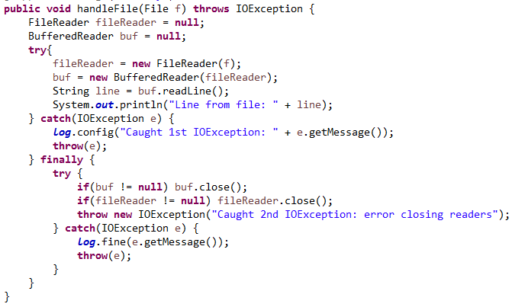

**Exercise.** We recall this scenario: A calling class for this code successfully opens the FileReader, but an IOException is thrown when readLine() is called. When the finally clause executes, another IOException is thrown when an attempt is made to close the Readers. The calling class catches an IOException and prints the message to the console.   
  
However, only one exception can be thrown, and in this scenario, the message displayed will be “Caught 2nd IOException: error closing reader.” The IOException indicating a failure to execute readLine() is lost.   
  
See demo lesson10.lecture.trickycatch1.MyClass2

This failing in pre-Java 8 has been corrected (and the entire try/catch construct greatly simplified) by the introduction of *try-with-resources.*

**The try-with-resources Solution**

Here is the Java 8 alternative to the previously displayed code: 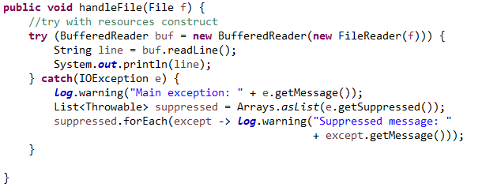

Demo: lesson10.lecture.trickycatch4_trywithres.MyClass  
  
The resources named in the arguments to try – in this case, a BufferedReader – will be closed at the completion of the try block. If an exception is thrown during execution of try and an error occurs in closing these resources, the close exceptions will automatically be appended to the main exception as *suppressed exceptions*. If no such main exception occurs, but a close exception occurs, the close exception is thrown in the usual way. Notice how it is now possible to read the suppressed exceptions using the getSuppressed() method, which returns a list of Throwables. These can be read and handled if desired, but the main exception is the one that is thrown and caught.

A resource is an object that must be closed after the program is finished with it. The try-with-resources statement ensures that each resource is closed at the end of the statement.

**Resources in Java 8 Which Can Be Used with try-with-resources**

Any object that implements java.lang.AutoCloseable, which includes all objects that implement java.io.Closeable, can be used as a resource. The classes in Java 8 that implement AutoCloseable are listed here:

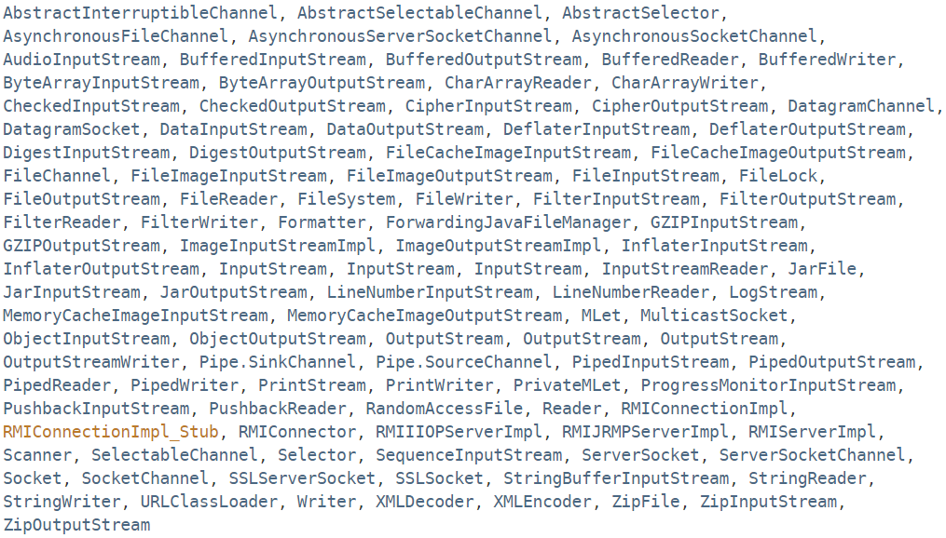

**Overview**

1. Test-Driven Development and Unit Testing (Optional Module #1)
2. Unit-testing Stream Pipelines
3. Introduction to Annotations
4. Review of Exception Handling in Java (Optional Module #2)
5. Handling Exceptions Using Java 8’s try-with-resources
6. **Review of Basic JDBC Programming (Optional Module #3)**
7. Advanced JDBC Programming
8. Handling Exceptions Arising in Stream Pipelines
9. Concurrent Processing and Parallel Streams

**Review of JDBC**(Optional Module #3)

Another example of a resource that can be managed with try-with-resources is the Connection object, invoked in interacting with a database, using JDBC. Handling exceptions and closing the connection in the right way and in the right sequence has tended to be error-prone. Using try-with-resources, it is straightforward to write code in the correct way.

1. ***Review of JDBC.*** JDBC is a mechanism that makes it possible for a Java program to communicate with a database system (and other similar data sources) by way of SQL (structured query language) commands.
2. JDBC APIs facilitate

* Making a connection to a database.
* Creating SQL or MySQL statements.
* Executing SQL or MySQL queries in the database.
* Viewing and modifying the resulting records.

1. Simplified code sample (from Oracle tutorial)

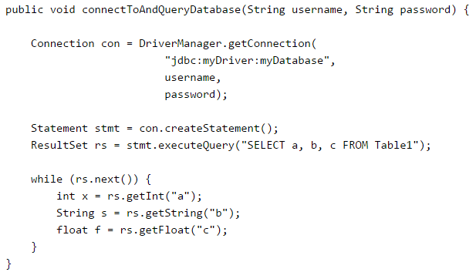

1. The JDBC Architecture

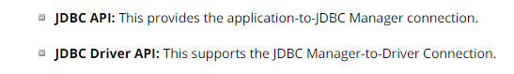

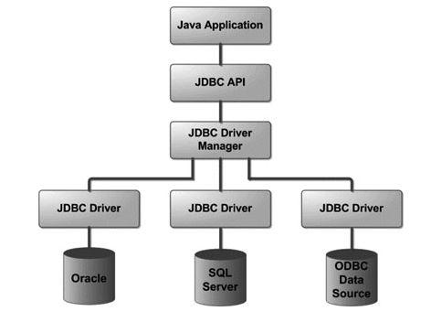

**Overview**

1. Test-Driven Development and Unit Testing (Optional Module #1)
2. Unit-testing Stream Pipelines
3. Introduction to Annotations
4. Review of Exception Handling in Java (Optional Module #2)
5. Handling Exceptions Using Java 8’s try-with-resources
6. Review of Basic JDBC Programming (Optional Module #3)
7. **Advanced JDBC Programming**
8. Handling Exceptions Arising in Stream Pipelines
9. Concurrent Processing and Parallel Streams

**Advanced JDBC Programming**

1. Begin with the example given in lesson10.lecture.jdbc.read_trywithres
2. As in the case of closing a Reader, if a SQLException is thrown in reading the database and another is thrown in attempting to close the Connection, the close exception is appended to the database exception as a suppressed exception.
3. The implementation style uses try-with-resources just to manage the Connection object; the steps of forming and executing a Statement are handled in an embedded try/catch block.

**Handling Transactions and Auto-Generated Keys with JDBC**

Transactions enable you to control if, and when, changes are applied to the database. It treats a single SQL statement or a group of SQL statements as one logical unit, and if any statement fails, the whole transaction fails.

To transaction support set the Connection object's autoCommit flag to false**.**  For example, if you have a Connection object named conn, code the following to turn off auto-commit −

conn.setAutoCommit(false);

Once you have executed your SQL code (for insertions, deletions,etc), you *commit* the changes with a call to the Connection object’s **commit()** method like this:

conn.commit( );

If an exception is thrown, you can rollback your changes to the database with a call to **rollback**:

conn.rollback( );

Exception-handling for transaction management can be tricky, but try-with-resources simiplifies the steps.

DEMO: lesson10.lecture.jdbc.transact

NOTES:

1. The demo illustrates the use of PreparedStatements. In a nutshell (for security reasons) whenever an SQL statement has parameters that need to be filled at runtime, the statement should be written using a PreparedStatement.
2. The Customer unique key field id is *auto-generated.* After you do an insert, you will often want to know what the value of the id that was generated by the database. The demo illustrates the technique for retrieving this value

RESOURCES:

JDBC and working with transactions are big topics. Here are two excellent follow-up resources:

1. <http://docs.oracle.com/javase/tutorial/jdbc/basics/transactions.html>
2. <http://www.tutorialspoint.com/jdbc/index.htm>

For practice with SQL, try:

1. <http://www.w3schools.com/sql/sql_intro.asp>

**Data Access and Frameworks**

1. For real production code, a more systematic approach to accessing the data source is followed. These days, systems rely on framework support, which provides an interface that gives you access not only to the database, but to a robust context for working with data, including transactional support, security and access control, data visualization, and perhaps most importantly, a uniform way of reading and writing data that hides the details of creating connections and executing statements.
2. Typically, you gain access to a framework solution simply by adding one or more jar files to your project.
3. *Two Approaches.* There are two styles of framework support these days
   1. *ORM* (object-relational mapping) – JPA and Hibernate use this approach
   2. *DAOs* (data access objects) – Spring supports this approach with its JDBC templating
4. JPA sample.
   1. Classes that need to be persisted (like Address, Customer, etc) are called *entities*
   2. In JPA, you insert annotations in an entity class to tell the framework information about reading and writing its data.  
       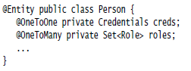
   3. An EntityManager is invoked to save entity classes to the database and also to read data from a table into one of the entity classes.

|  |  |
| --- | --- |
|  |  |
| **Persisting/Removing** | **Reading** |

1. DAO Sample. In the DAO approach, classes that are persistent (Address, Customer, etc) are associated with corresponding DAO classes, which know how to interact with the data access layer. For instance, a Customer class would be associated with a CustomerDao. Reads and writes of Customer are then facilitated by CustomerDao.

See demo: lesson10.lecture.jdbc.framework; your must add dataaccess.jar to the project  
  
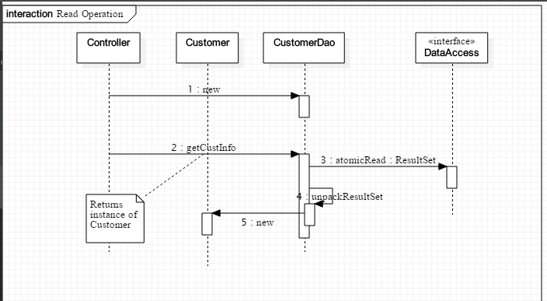  
  
  
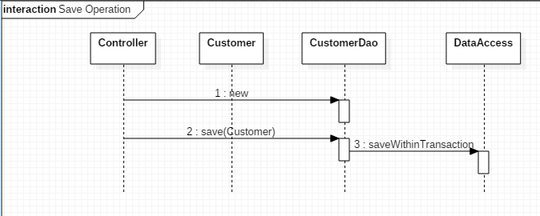

**Overview**

1. Test-Driven Development and Unit Testing (Optional Module #1)
2. Unit-testing Stream Pipelines
3. Introduction to Annotations
4. Review of Exception Handling in Java (Optional Module #2)
5. Handling Exceptions Using Java 8’s try-with-resources
6. Review of Basic JDBC Programming (Optional Module #3)
7. Advanced JDBC Programming
8. **Handling Exceptions Arising in Stream Pipelines**
9. Concurrent Processing and Parallel Streams

**Handling Exceptions Arising in Stream Pipelines**

1. Ordinary functional expressions, composed in a pipeline, may throw exceptions, but very often exception-handling can be done in the usual way. See demo code in lesson10.lecture.exceptions.
2. However, stream operations, like map and filter, that require a functional interface whose unique method *does not have a throws clause* (like Function and Predicate), make exception-handling more difficult. See demo code to see issues and best possible solutions.  
   lesson10.lecture.exceptions2
3. The best one can do in these situations is to convert checked exceptions to RuntimeExceptions. The code can be made more readable and compact if the try/catch clause that is needed can be tucked away in an auxiliary method. Examples are provided in lesson10.lecture.exceptions3, lesson10.lecture.exceptions.connectold, and lesson10.lecture.exceptions.connectnew

**Main Point 2**

Associated with exception-handling in Java are many well-known best-practices. For example: exceptions that can be caught and handled – *checked exceptions –* reflect the philosophy that, if a mistake can be corrected during execution of an application, this is better result than shutting the application down completely. Secondly, one should never leave a caught exception unhandled (by leaving a catch block empty). Third, one should never ask a catch block to catch exceptions of type Exception because doing so tends to be meaningless.

Likewise, Maharishi points out that, in life, it is better not to make mistakes, but, if a mistake is made, it is best to handle it, to apologize, so that the situation can be repaired; it is never a good idea to simply “ignore” a wrongdoing that one has done. Repairing a wrongdoing requires proper use of speech; an “apology” that does not really address the issue may be too general and may do more harm than good.

**Overview**

1. Test-Driven Development and Unit Testing (Optional Module #1)
2. Unit-testing Stream Pipelines
3. Introduction to Annotations
4. Review of Exception Handling in Java (Optional Module #2)
5. Handling Exceptions Using Java 8’s try-with-resources
6. Review of Basic JDBC Programming (Optional Module #3)
7. Advanced JDBC Programming
8. Handling Exceptions Arising in Stream Pipelines
9. **Concurrent Processing and Parallel Streams**

**Concurrent Processing and Parallel Streams  
Overview**

1. Introduction to threads
2. Working with threads: the Runnable interface
3. Thread safety and the synchronized keyword
4. Java 8 convenience class for invoking threads: the Executor class
5. When should you use parallel streams?

**Introduction to Threads**

1. A *process* in Java is an instance of a Java program that is being executed. It contains the program code and its current activity. A process has a self-contained execution environment. A process generally has a complete, private set of basic run-time resources; in particular, each process has its own memory space.

2. A *thread* is a component of a process. Multiple threads can exist within the same process, executing concurrently (one starting before others finish) and sharing memory (and other resources), while different processes do not share these resources. In particular, the threads of a process share the values of its variables at any given moment.

3. Every process has at least one thread, the *main thread* (the main method of a Java program starts up the main thread.) Other threads may be created from the main thread.

4. Multiple threads are typically invoked to perform multiple tasks simultaneously, or to simulate simultaneous execution of multiple tasks. In a multiprocessor environment, different threads can access different processors; in a single processor environment, multiple threads can appear to work simultaneously by virtue of *time-slicing* – the operating system allots portions of time to competing threads.

5. Examples of how multiple threads are used:

a. One thread keeps a UI active while another thread performs a computation or accesses a database

b. Divide up a long computation into pieces and let each thread compute values for one piece, then combine the results (computing in parallel)

c. Web servers typically handle client requests on separate threads; in this way, many clients can be served “simultaneously.”

**Creating Threads in Java**

Code that you wish to run in a new thread is contained in the run() method of a class that implements the Runnable interface.   
  
 interface Runnable {  
 void run() ;  
 }  
  
 class MyRunnable implements Runnable {

public void run() {

System.out.println(“Running a thread!”);

}

}

The thread is then *spawned* when an instance of your class is used as an argument to the Thread constructor, and the start() method is called on the Thread instance.

The following code creates a thread and starts it::

MyRunnable myRunnable = new MyRunnable();

Thread t = new Thread(myRunnable);

t.start();

Runnable is a functional interface. Therefore, starting a new Thread can be done using lambdas:  
  
 Thread t = new Thread(() -> System.out.println(“Running a thread”));  
 t.start();

**Testing Singleton Using a Single Thread**

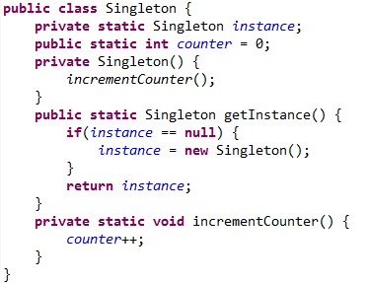

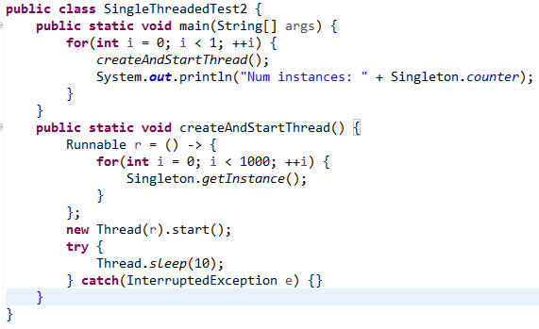

As expected, only 1 instance is ever created.  
  
Note: We have put each thread to sleep for 10 milliseconds before allowing the next one to start. If we do not do this, then the first 1 or 2 calls of createAndStart will record *0 instances.* This is because the change made by each thread may not be visible to the main thread immediately (this is most likely because processor memory is much faster than the RAM where the counter data is stored).

**Testing Singleton Using Multiple Threads**



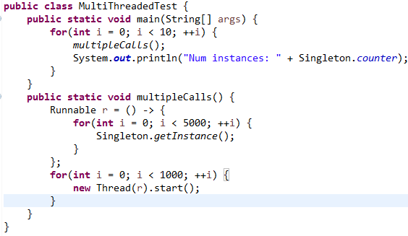

The test shows that competing threads are creating multiple instances of the Singleton class. The test “instance == null” is being interrupted so that it appears to be true to more than one thread, and so the constructor is called multiple times.

**Race Conditions and Thread Safety**

1. When two or more threads have access to the same object and each modifies the state of the object, this situation is called a *race condition,* which arises when threads *interfere* with each other (the sequence of steps being executed by one thread is interrupted by another thread).

2. Code is said to be *thread-safe* if it is guaranteed to be free of race conditions when accessed by multiple threads simultaneously.

3. We can say therefore that this Singleton implementation is *not thread-safe.*

**Forcing Serialized Access with synchronized**

1. We can force threads to access the getInstance method of Singleton *one at a time* (this is called *serialized access*) by labeling getInstance with the keyword synchronized.

2. When a method is synchronized, in order for a thread to execute the method, it must *acquire the lock* for the instance of the object that the method is running on. Each object has an instrinsic lock, and a thread gains access to this lock when it calls the method, as long as no other thread has the lock. Once a thread executes the synchronzied method, the lock becomes available again and the next eligible thread (determined by the OS using thread priorities and other factors) then acquires the lock.

*Note*: This use of the word “serialized” has nothing to do with the Serializable interface that we examined earlier in the course

*Note:* We have seen that competing threads could corrupt the “== null” test. However, competing threads could also corrupt the counter since the increment operation counter++ is not atomic (it is in fact the assignment counter = counter + 1). Therefore, to be sure that the MultiThreadedTest is really producing multiple instances of Singleton, we must make the incrementCounter method synchronized, as in the code below. Running this test, and witnessing multiple calls to the Singleton constructor once again convinces us that multiple instances are being created.

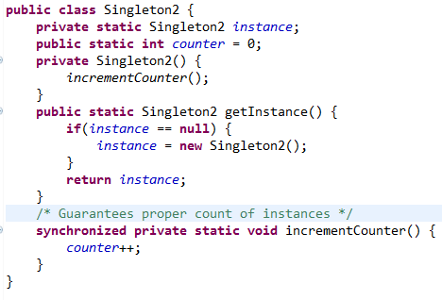

**Starting and Managing Threads with Executor**

1. When an application relies heavily on multi-threading, either because many threads are needed, or because threads need to be managed carefully, the “manual” approach to starting threads shown above is not optimal. To create and manage threads properly, Java has an Executor class.

2. Two examples of specialized Executor classes are those created by the factory methods Executors.newCachedThreadPool(), which is optimized for creation of threads for performing many small tasks or for tasks which involve long wait periods. For computationally intensive tasks, Java provides Executors.newFixedThreadPool(numThreads).

3. We modify our earlier code to make use of this the Executor class. We synchronize the getInstance method in SynchronizedSingleton.  
  
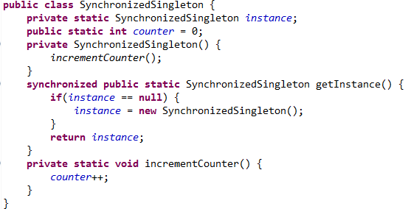

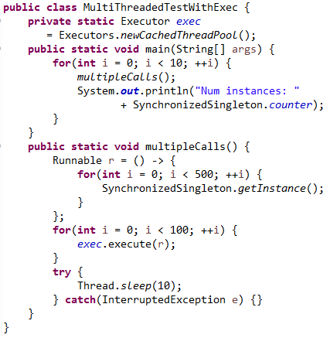

**Note**: You may notice that the program waits a bit after the last printout. It terminates when the pooled threads have been idle for a while; after some time, the executor terminates them.

**Guidelines for Using Parallel Streams**

1. When you create a parallel stream from a Collection class in order to process elements in parallel, Java handles this request by partitioning the collection and processing each piece with a separate thread. Not every Stream operation, nor every underlying collection type, is amenable to parallel processing. We give general guidelines for choosing between sequential and parallel streams.

2. Some Guidelines

A. Don’t use parallel streams if the number of elements is small – the improved performance (if any) will not in this case outweigh the overhead cost of working with parallel streams.

B. Operations that depend on the order of elements in the underlying collection should not be done in parallel. Example: findFirst, limit.

C. If the terminal operation of the stream is expensive (example: collect(Collectors.joining)), you must remember that it will be executed repeatedly in a parallel computation – this could be a good reason to avoid parallel streams in this case.

D. Translation between primitives and their object wrappers becomes very expensive when done in parallel. If you are working with primitives, use the primitive streams, like IntStream and DoubleStream.

E. Certain data structures can be divided up more efficiently than others – ArrayList, HashSet and TreeSet can be partitioned efficiently, but LinkedLists cannot.

F. Until you develop a degree of expertise in working with parallel computations, it is a good idea to benchmark the performance of a pipeline executed in parallel and compare with the performance of the sequential version.

Sample Benchmarks for Sequential vs Parallel Processing

Warburton, *Java 8 Lambdas* (p. 84) gives an example of a benchmark test that makes a convincing case for choosing parallel processing over sequential processing for a particular task.

Sequential Version of Code

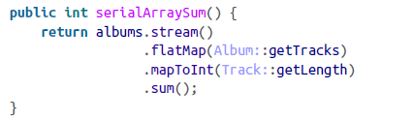

Parallel Version of Code

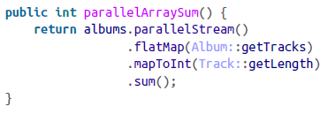

Warburton reports that, when running on a quad core Windows machine, when the number of albums was just 10, the sequential version was 8x faster; when number of albums was 100, the two versions were equally fast; when the number of albums was 10,000, the parallel version was 2.5x faster.

# Connecting the Parts of Knowledge With the Wholeness of Knowledge

# Annotations

|  |  |
| --- | --- |
| 1. Executing a Java program results in algorithmic, predictable, concrete, testable behavior.   2. Using annotations, it is possible for a Java program to modify itself and interact with itself.  3*. Transcendental Consciousness* is the field self-referral pure consciousness. At this level, only one field is present, continuously in the state of knowing itself.  4*. Impulses Within the Transcendental Field*. What appears as manifest existence is the result of fundamental impulses of intelligence within the field of pure consciousness. These impulses are ways that pure consciousness acts on itself, interacts with itself.  5*. Wholeness Moving Within Itself.* In Unity Consciousness, the diversity of creation is appreciated as the play of fundamental impulses of one’s own nature, one’s own Self. | arrow |